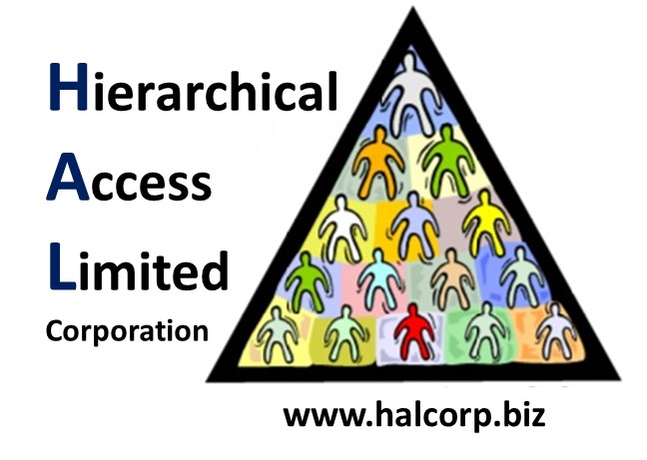

Internal Memorandum

To: Paula Alexander <hal.cio@seccdc.org>

CC: judge_29@seccdc.org

From: Team 9

Date: February 23, 2019

Memo #: 001

Re: Welcome to the 2019 Southeast CCDC Qualifier

Greetings CIO,

We would like to notify you that our team is ready to compete. Our workstations are fully functional and we are able to connect to the environment. We have received a copy of the team packet and agree to abide by the rules stated therein.

Regards,

Team 9

*In accordance with HAL Memorandum policy, the entire header must be completed or the recipient may not acknowledge this as an official memorandum. Professional communications methods and decorum must be observed at all times.*